**EC2 Basics Lab**

1. 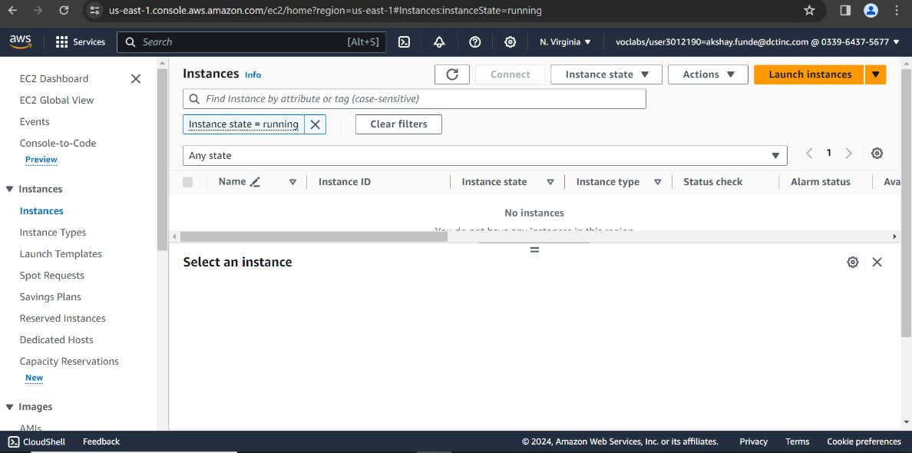Launch Instances Ec2 Basic1
2. 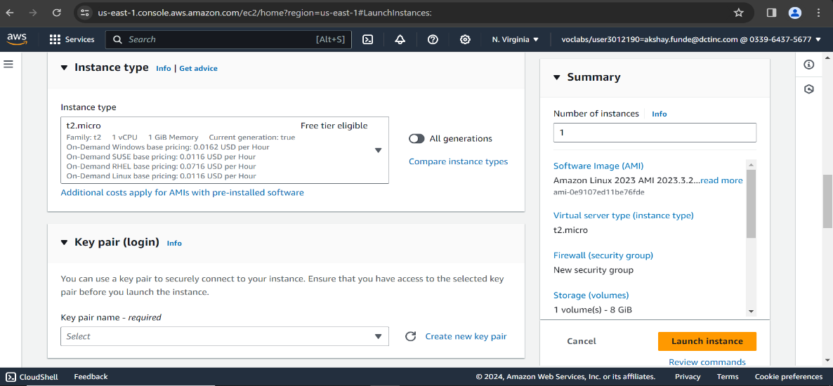Selecting appropriate Instance Type t2.micro
3. 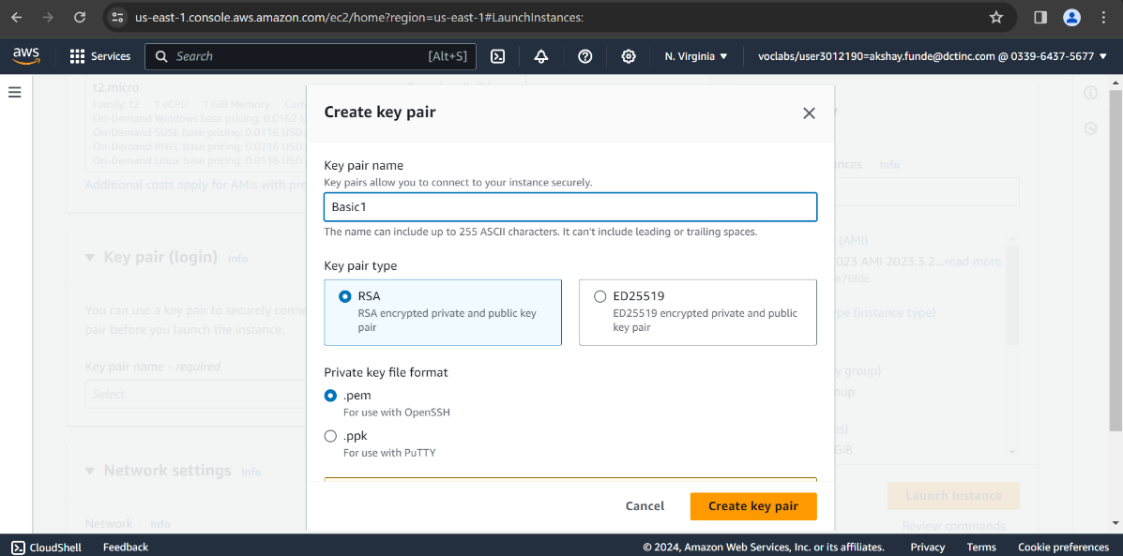Create new Key Value Pair Basic1
4. 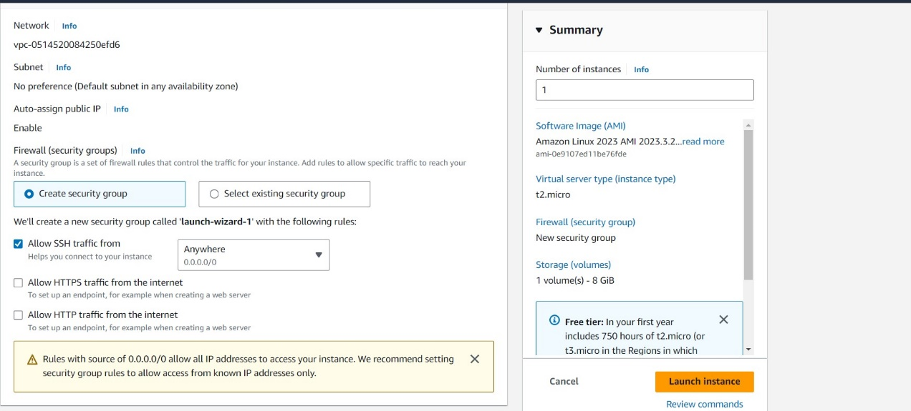Set address in security group as anywhere for accessing site from any Ip Address
5. Launched Instance and Status Is Running

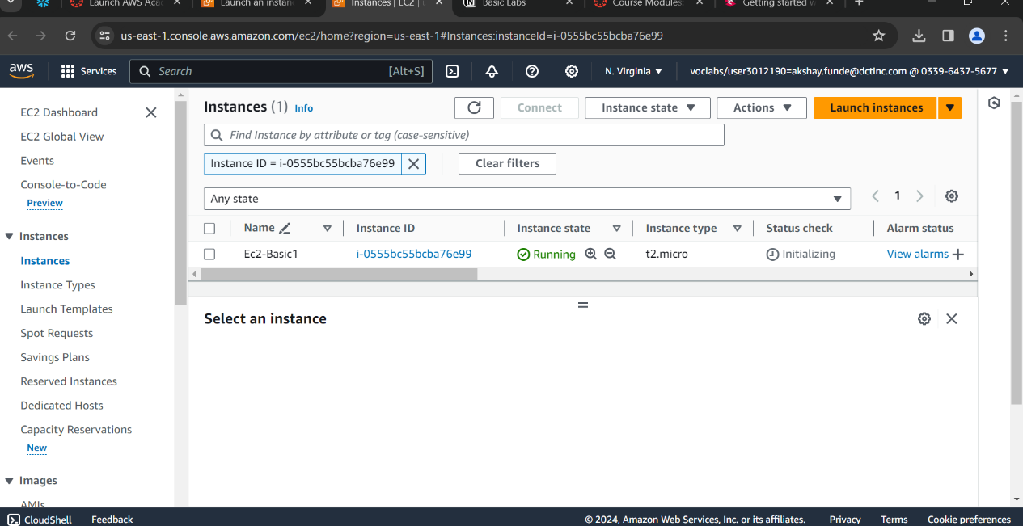

1. 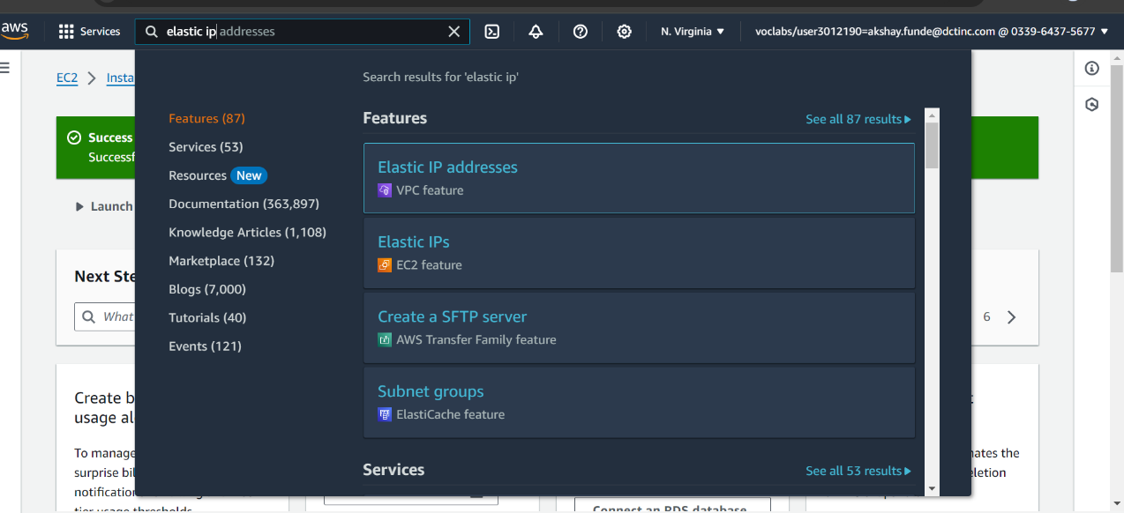Selecting Elastic IP’s for Ec2 Instance
2. 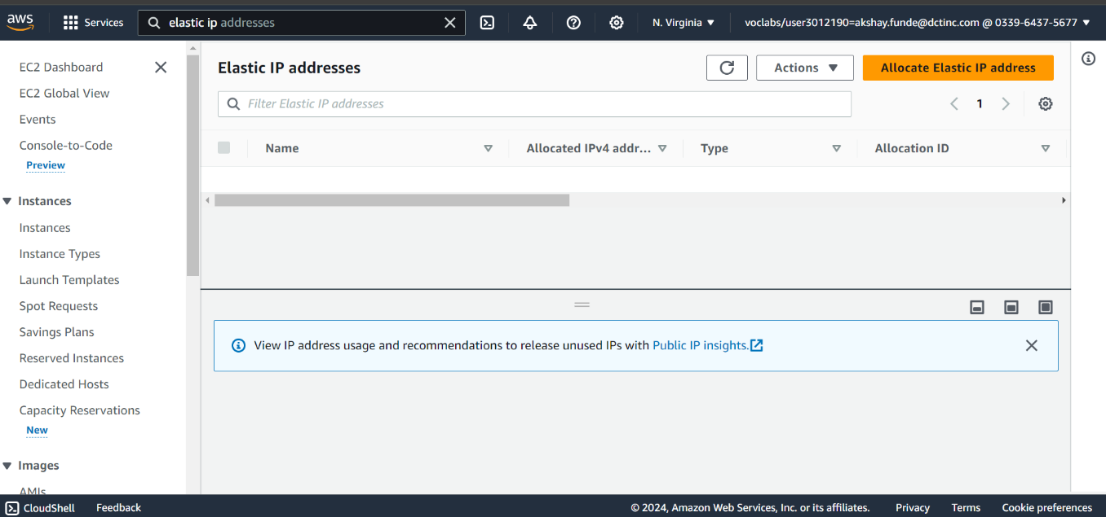Allocating Elastic IP address
3. 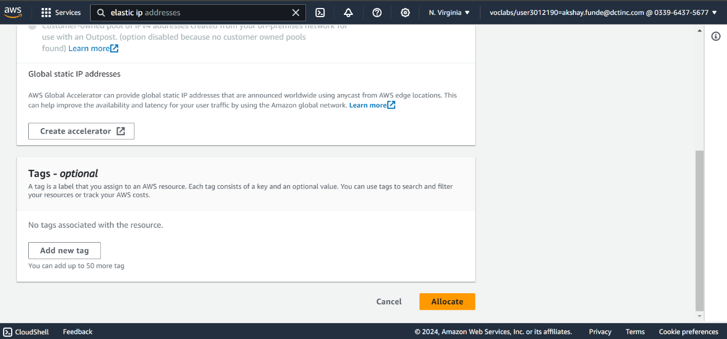Scroll down and allocate It.
4. 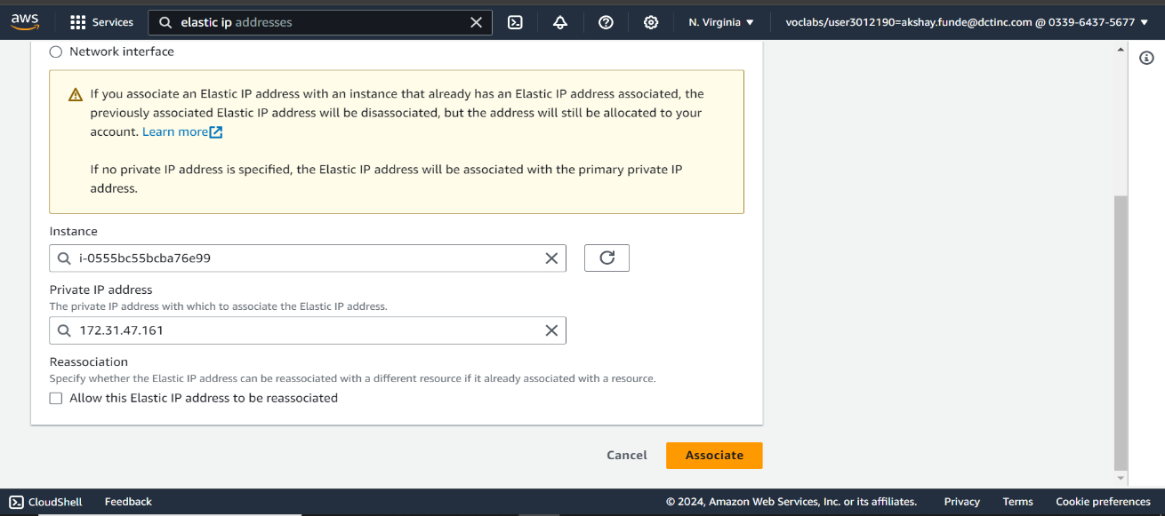Select Instances id and private Ip Address.
5. 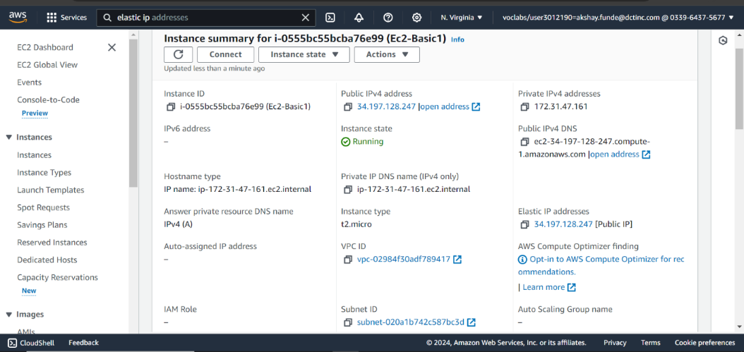**Elastic Ip Address get associated with our EC2 Instance**
6. 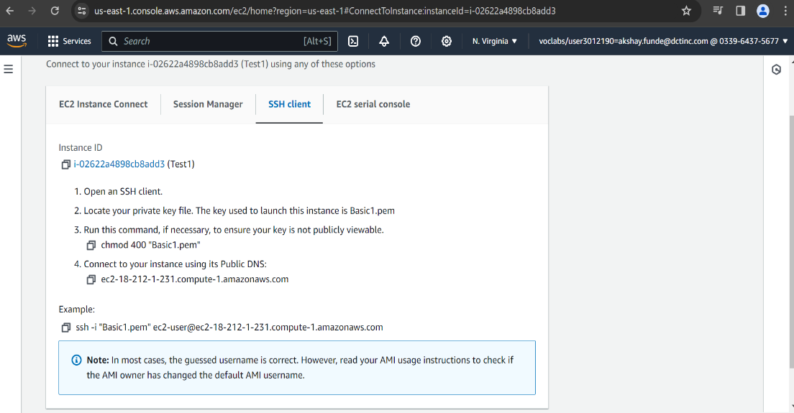**Connecting to the instance via SSH**
7. 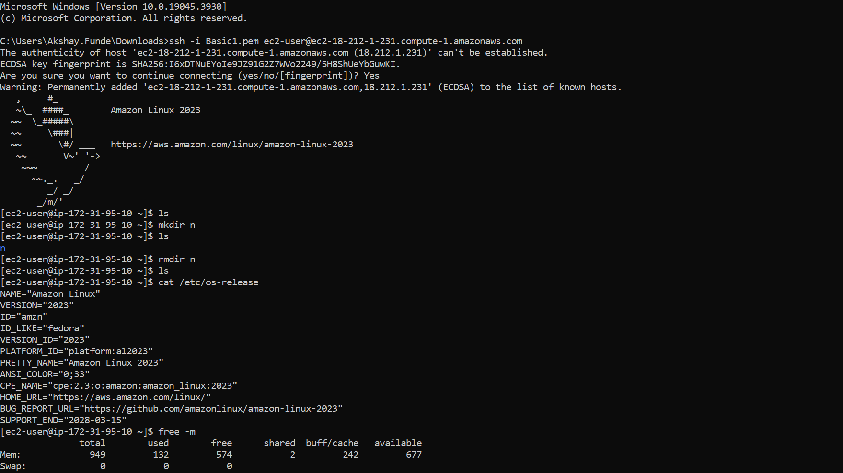**Access EC2 Instance connected via SSH to the local pc.**

**S3 Storage Fundamentals Lab**

1. 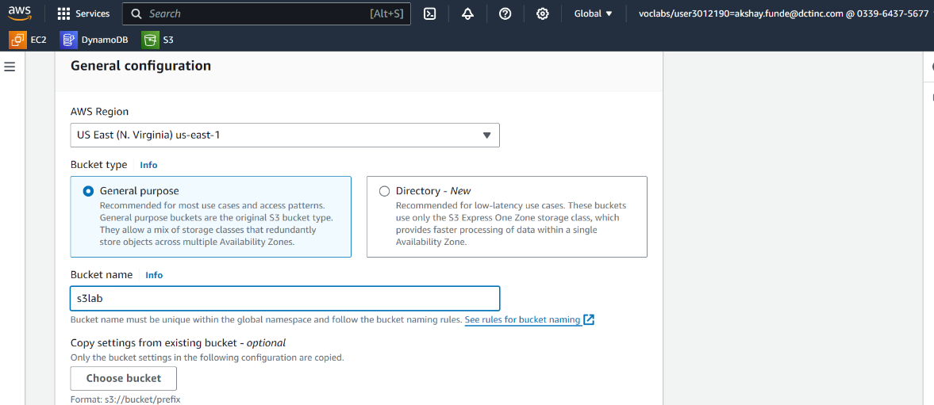**Creating s3 bucket with unique name**
2. 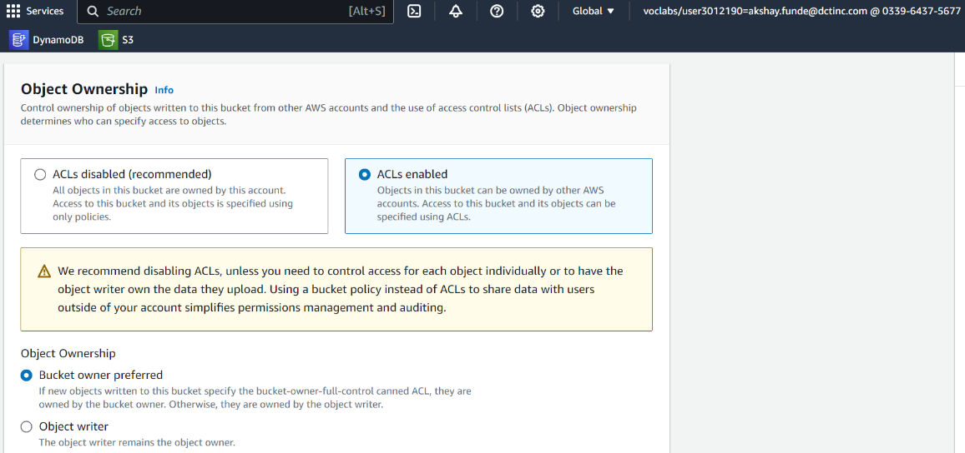**Object Ownership: Select ACL’s Enabled for the public.**
3. 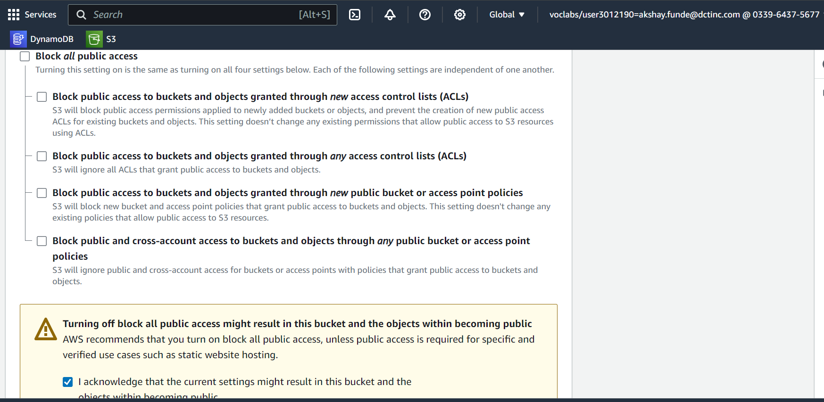Untick block all public access option because the object is public and tick acknowledgement request.
4. 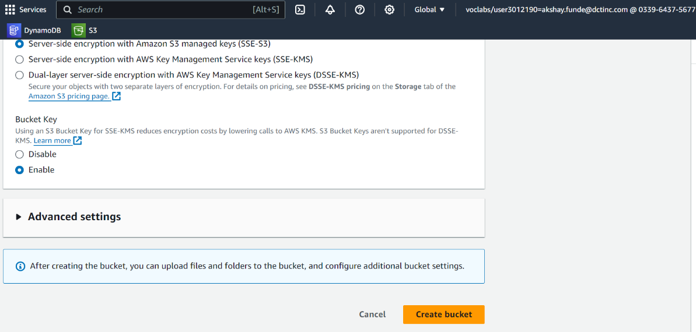**Now created the bucket.**
5. 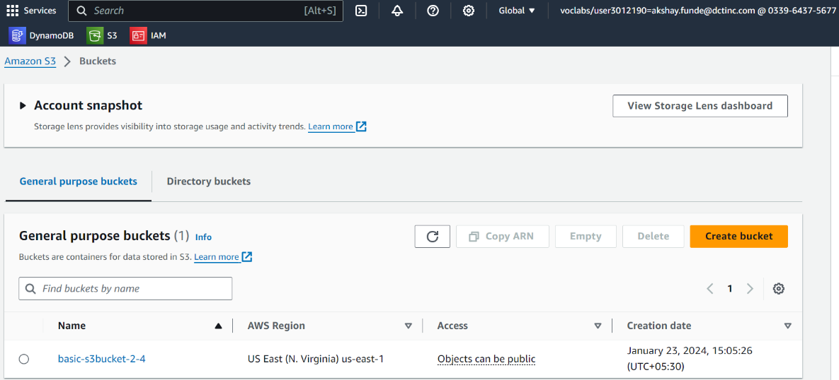 **The bucket was created successfully. After that select the bucket to upload the data**
6. 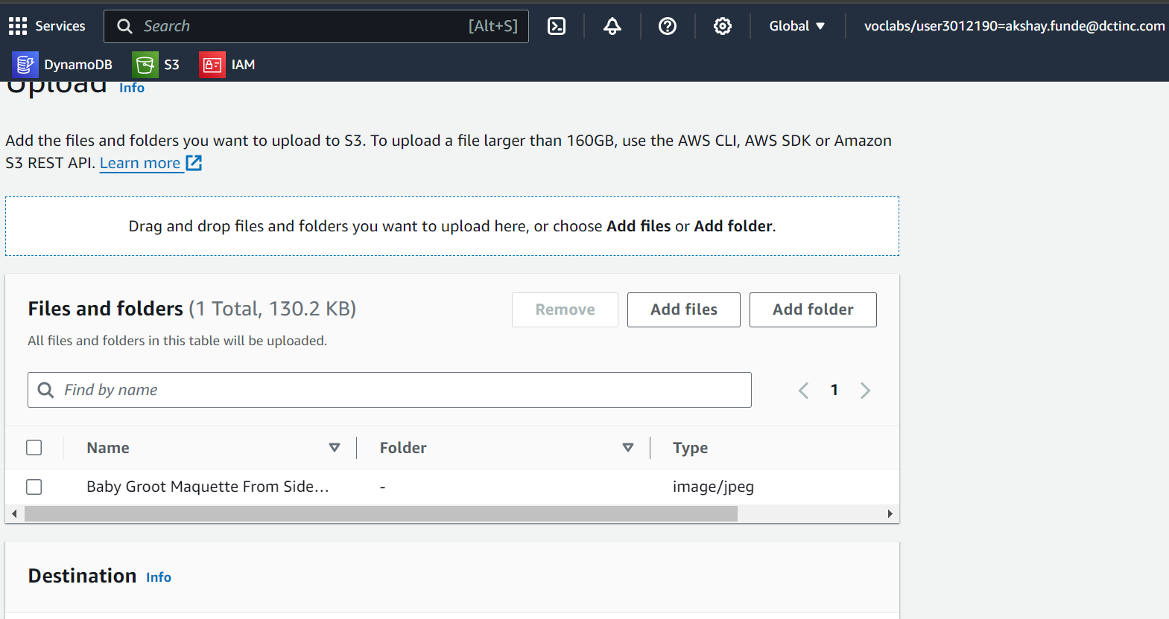**File uploaded from the add files button.**
7. 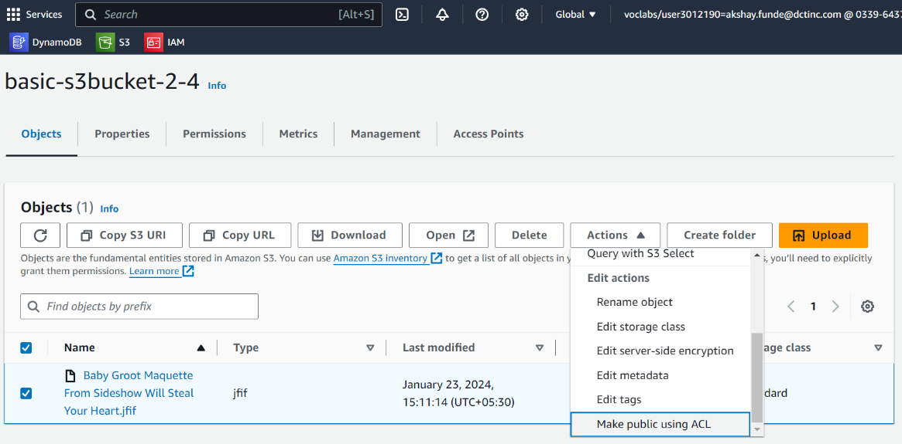**Make uploaded file public for public access by clicking on action button and then select the make public using ACL option.**
8. **Clicked on the make public option.**

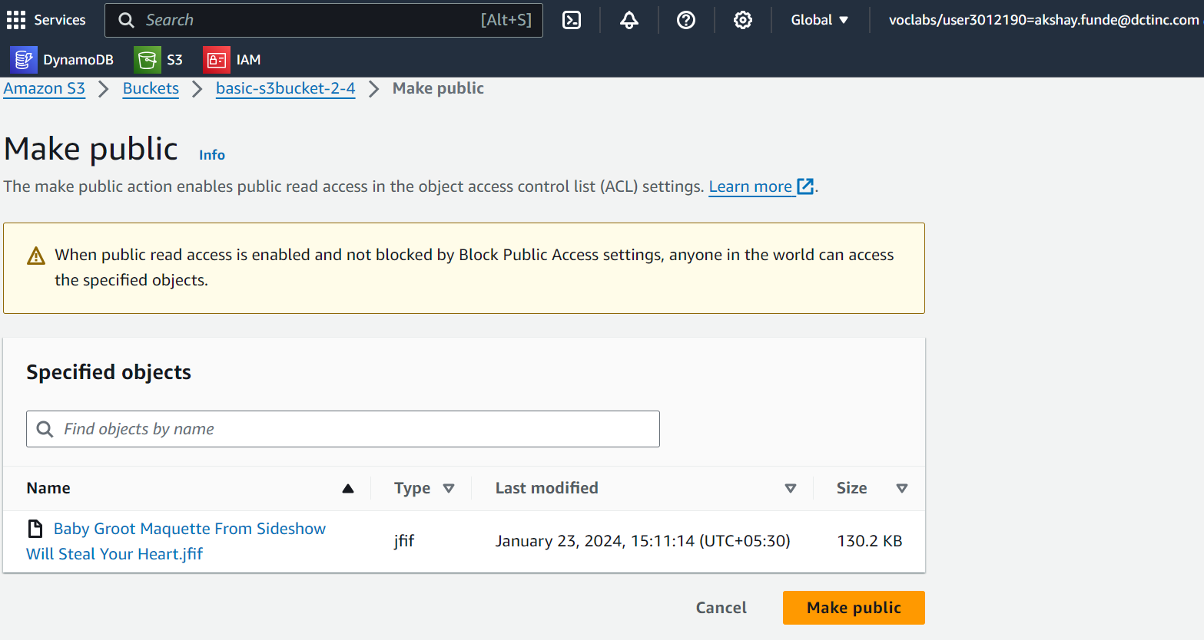

1. 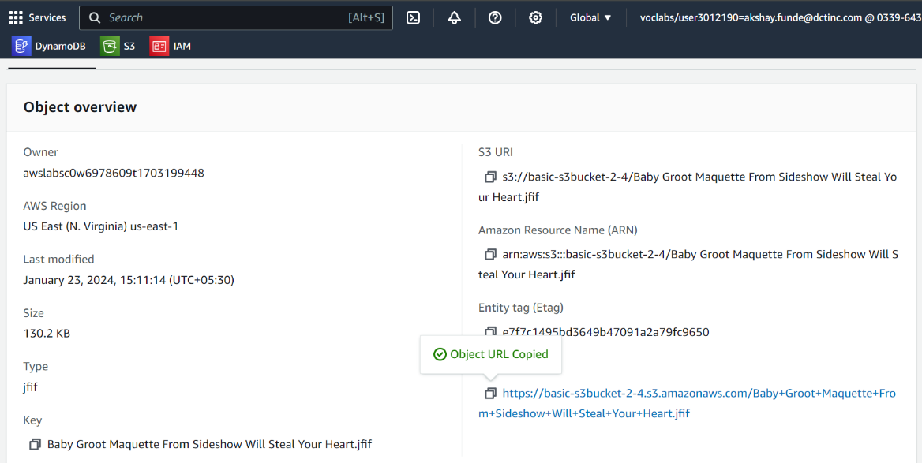**Public URL is generated to access the file.**
2. **Object file uploaded in S3 Bucket**



**IAM Users and Roles Lab: -**

1. **Creating new IAM user by add user button.**

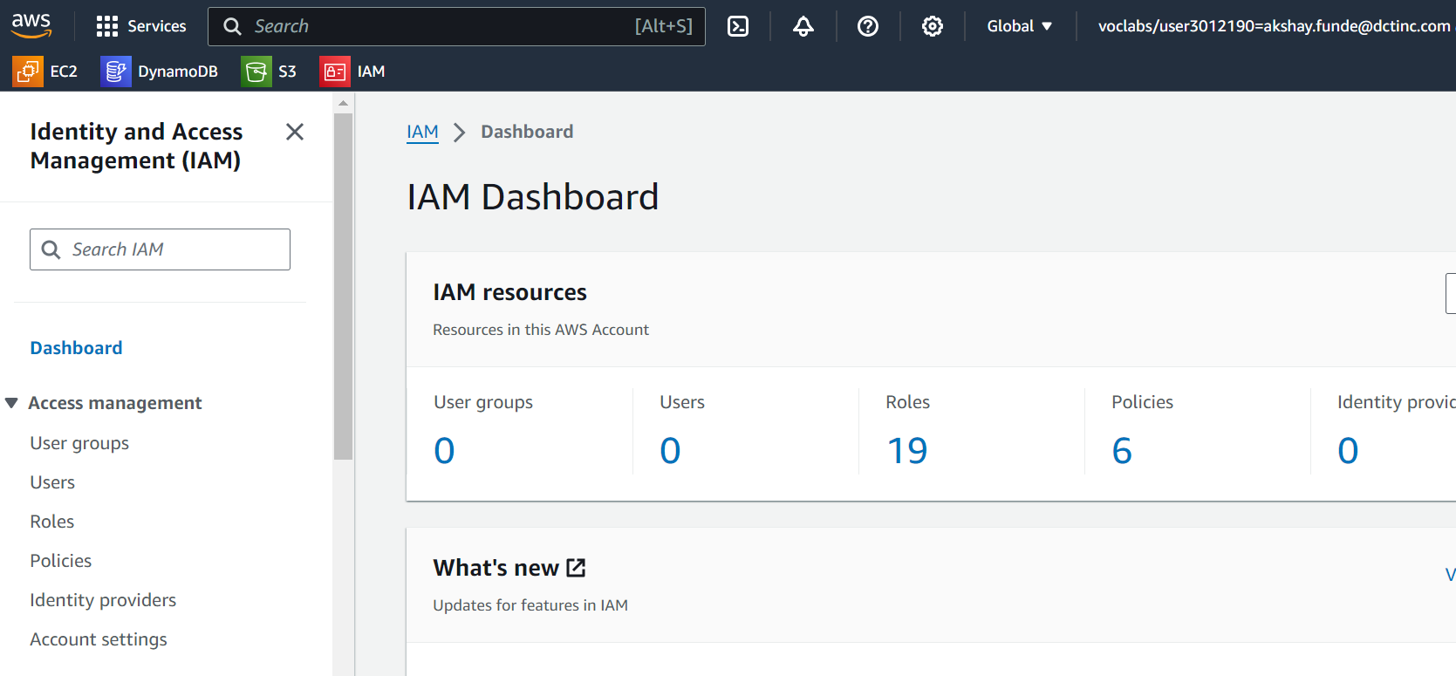

1. **Step 1: Specify user details by custom password**

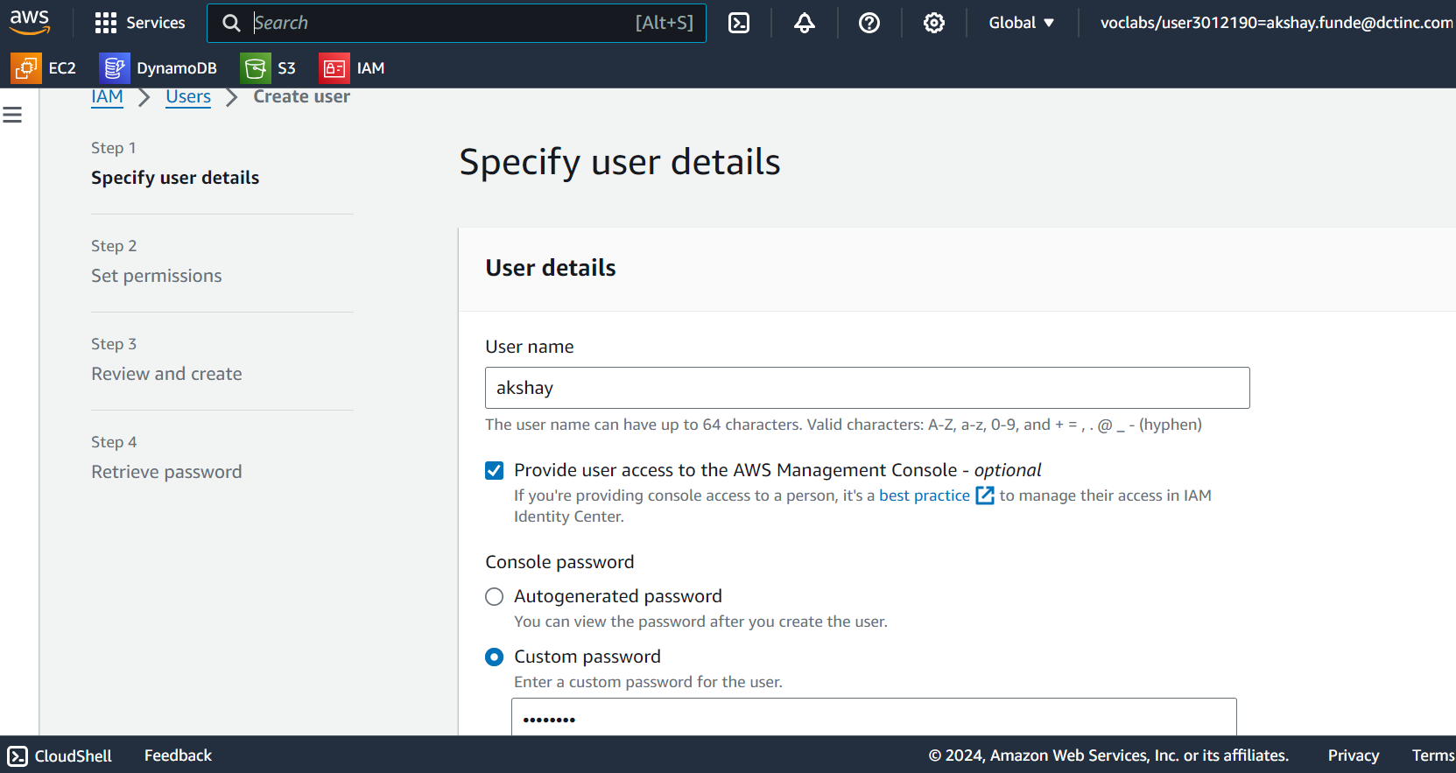

1. **Step 2: Set permissions to add user to group.**

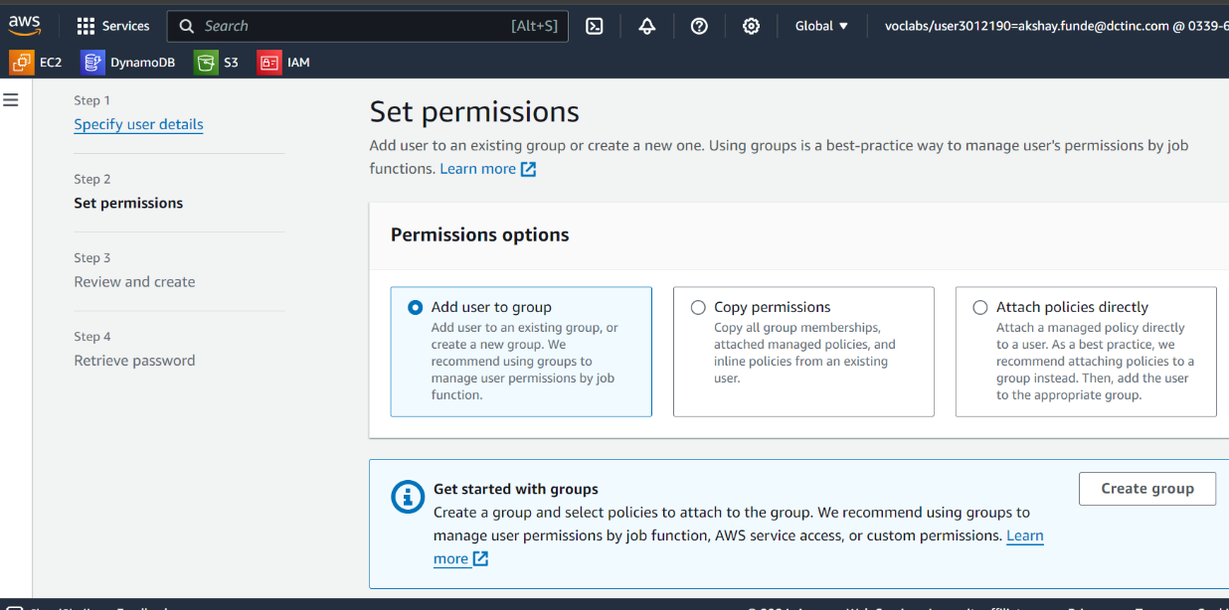

1. **Step 3: Reviewed before creating the user**

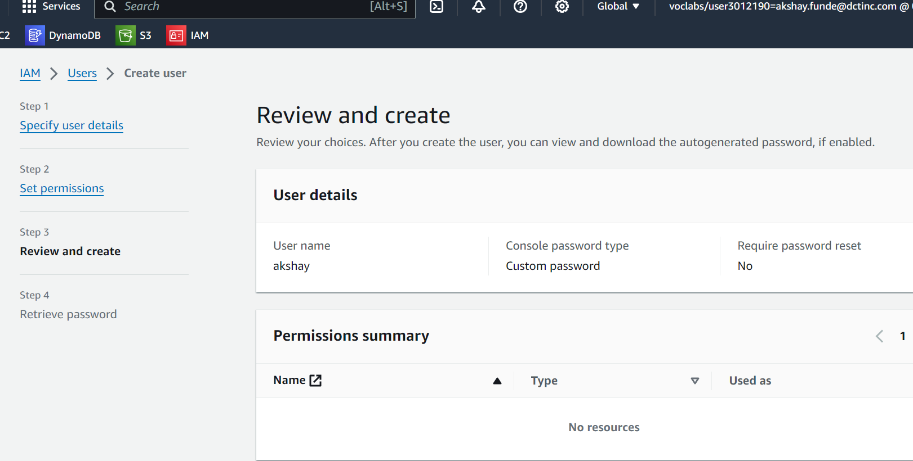

**3. VPC Configuration Lab**

**Steps**

1. **Create VPC with vpc setting vp**
2. **Then, create two subnets Private and public with IPv4 10.0.1.0/24 and 10.0.0.0/24**
3. **Create Internet Gateway**
   1. **Attach created gateway to VPC**
4. **Create Route tables**
   1. **Associate it with subnet**
   2. **Attach internet gateway in edit routes**
5. **TO create a webserver in EC2 instance**
   1. **In Network setting select created vpc**
   2. **Select Public subnet**
   3. **Also, Add SSH and HTTP inbound security group rules.**
   4. **After creating connect it**
   5. **Now enter appropriate command to do**
   6. [Deploy your first hello world application on AWS EC2 Instance | by Rohit Jain | Medium](https://medium.com/@rj03012002/deploy-your-first-hello-world-application-on-aws-ec2-instance-e474028964a9)
      1. ssh -i "C:\Users\Akshay\Downloads\vpc09.pem" [ec2-user@3.83.179.137](mailto:ec2-user@3.83.179.137)
      2. sudo su
      3. yum update -y  
         yum install httpd
      4. cd /var/www/html
      5. sudo chown -R $USER /var/www/html
      6. sudo chmod 777 /var/www/html
   7. **open command prompt from .pem file location**
      1. scp -i "vpc09.pem" "index.html" [ec2-user@3.83.179.137:/var/www/html/index.html](mailto:ec2-user@3.83.179.137:/var/www/html/index.html)
6. End of task for Linux
7. For Windows
   1. Create new instance with windows
   2. Add security group with inbound rule rdb and http
   3. From rdp client download remote desktop file
   4. Open remote desktop connection
   5. Generate password for it from rds client
   6. Then connect with local resource
   7. Then install python to the virtual machine
   8. With python upload html file to localhost
      1. Search for localpost:8000



